|  |  |  |
| --- | --- | --- |
| **EX.NO :07** | **Inter-VLAN Routing** | **REG.NO: URK22AI1015** |
| **DATE: 04 - 10 -2023** |

# AIM

To design a network topology and configure Inter VLAN using packet tracer and test the connectivity between all the hosts in every VLANs.

**DESCRIPTION**

Inter-VLAN routing refers to the movement of packets across the network between hosts in different network segments. VLANs make it easier for one to segment a network, which in turn improves the performance of the network and makes it more flexible, since they are logical connections. VLANs act as separate subnet on the network.

# CONFIGURATION COMMANDS

Switch>en Switch#conf t

Enter configuration commands, one per line. End with CNTL/Z.Switch(config)#int fa0/1

Switch(config-if)#switchport mode access Switch(config-if)#switchport access vlan 10 Switch(config-if)#int fa0/2

Switch(config-if)#switchport mode access Switch(config-if)#switchport access vlan 10 Switch(config-if)#int fa0/3

Switch(config-if)#switchport mode access Switch(config-if)#switchport access vlan 20 Switch(config-if)#int fa0/4

Switch(config-if)#switchport mode access Switch(config-if)#switchport access vlan 20 Switch(config)#int gig0/1

Switch(config-if)#switchport mode access Switch(config-if)#switchport access vlan 10 Switch(config-if)#int gig0/2

Switch(config-if)#switchport mode access Switch(config-if)#switchport access vlan 20 Switch(config-if)#end

# CONFIGURATION COMMANDS(Router)

Router>en Router#conf t

Enter configuration commands, one per line. End with CNTL/Z. Router(config)#int fa0/0

Router(config-if)#ip addr 192.168.10.1 255.255.255.0 Router(config-if)#no sh

Router(config-if)#int fa1/0

Router(config-if)#ip addr 172.168.10.1 255.255.0.0 Router(config-if)#no sh

Router(config-if)#end

# PROCEDURE

1. Configure IP Addressing on the Host PCs.
2. Configure Routers Interfaces.
3. Configure the routers to install the VLAN configuration in the switch and router.
4. Test and Verify the Configurations.

# TOPOLOGY DIAGRAM

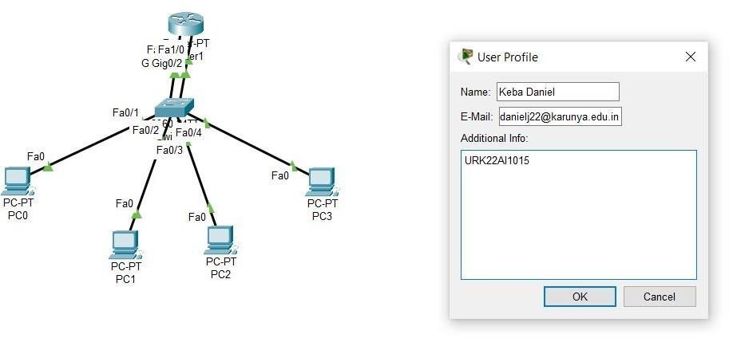

**ADDRESSING TABLE**

|  |  |  |  |  |
| --- | --- | --- | --- | --- |
| **Device** | **Interfac e** | **IP Address** | **Subnet Mask** | **Default Gateway** |
| R0 | Fa0/0 | 192.168.10.0 | 255.255.255.0 | NA |
| Fa1/0 | 172.168.20.0 | 255.255.0.0 | NA |
| PC0 | NIC | 192.168.10.2 | 255.255.255.0 | 192.168.10.1 |
| PC1 | NIC | 192.168.10.3 | 255.255.255.0 | 192.168.10.1 |
| PC2 | NIC | 172.168.20.2 | 255.255.0.0 | 172.168.20.1 |
| PC3 | NIC | 172.168.20.3 | 255.255.0.0 | 172.168.20.1 |

# OUTPUT

**Screenshot of successful ping from PC to Router**

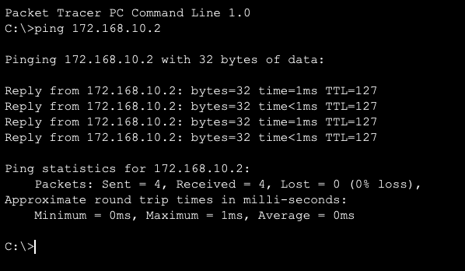

# Screenshot of show running-config of Switch

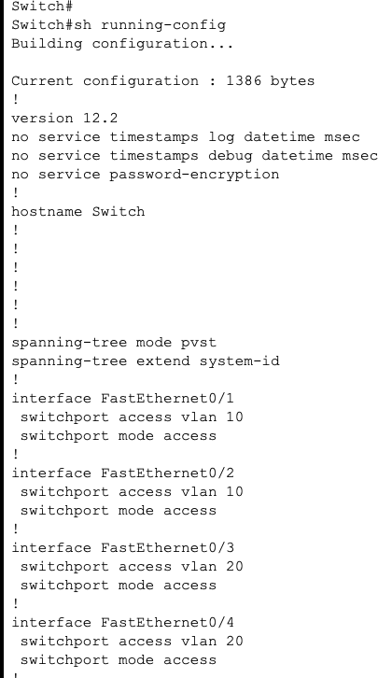

**Screenshot of Routing Table of the Router**

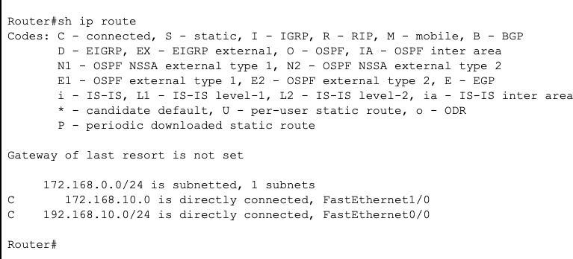

# Screenshot of Show vlan

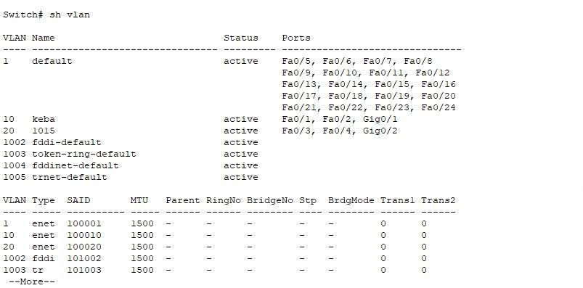

**Screenshot of Show vlan brief**

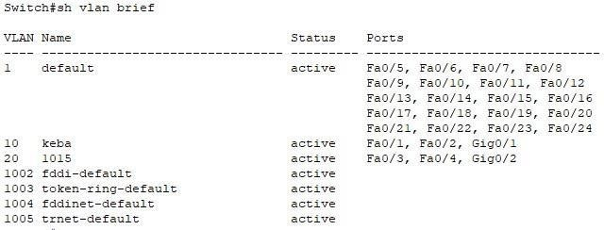

# Screenshot of Trunk Interfaces

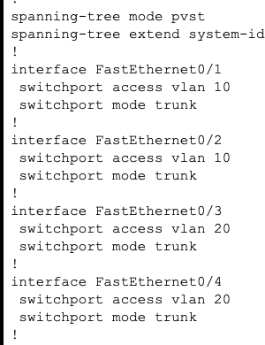

**Screenshot of Switchport**



# RESULT:

The above topology was created and the required vlans was created and the packets where transferred between the desired pc in the vlans.